# **Buggy Car Rating Web Site Automation Document**

This is the documentation for the automation scenarios for the BuggyCar Rating web site. (<https://buggy.justtestit.org/>). Top 5 scenarios have been selected to cover all the critical functionalities of the web site.

## Requirements

* Java
* Eclipse ide
* Selenium
* TestNG
* Extent Reports
* Chrome web driver according to Chrome browser version

Import project and execute

1. First unzip the project folder and insert it into eclipse.
2. Then you can execute test cases using TestNG.
3. Report will be generated in your project location under Reports folder

## Executing steps

Step 1 : After importing project into eclipse expand the testcases package.

Step 2 : Right click on test case you need to execute and click on TestNG to execute test case using TestNG.

## How to set up TestNG in eclipse ide

TestNG - One of the most popular automation testing frameworks for Java is TestNG. TestNG was inspired by JUnit and NUnit. If TestNG is not enabled in your eclipse ide, follow the steps to add TestNG configurations.

Step 1 : After Eclipse has started, select Help, and then select Eclipse Marketplace.

Step 2 : You would then need to type "TestNG" into the Find text field in the newly opened window and press the Go button.

Step 3 : The search results are now displayed, with TestNG for Eclipse at the top. Now all you have to do is select the Install button that is located next to it.

Step 4 : After the features have been resolved, which could take a few minutes, you must confirm that the TestNG checkbox is selected and click the Confirm button.

Step 5 : Choose “Keep my installation the same” option and again click on the Confirm button.

Step 6 : Accept the license and click on the Finish button.

You must restart Eclipse for the update to take effect, after which you can see that TestNG is installed by right-clicking on any project and finding TestNG in the list of menu options.

If you cant still see TestNG after right clicking testcase,  
 1 : go to run as and select run configuration

2 : Then click on Browse button on Class row

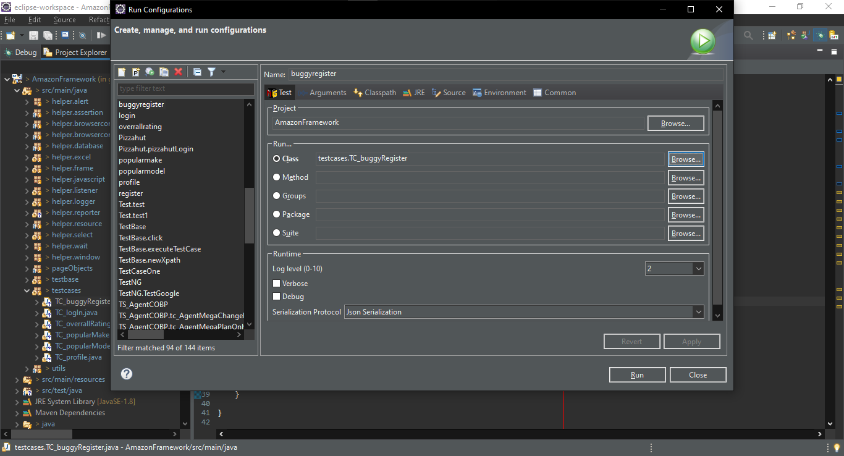

3 : Then select Test Case you want to execute and press OK

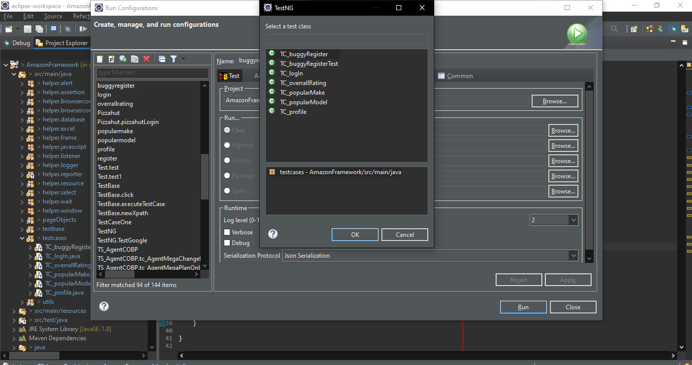

4 : Then click Apply and Run. Now Test case will execute



## Test Scenario 1

New user registration and login

## Test Scenario 2

Vote for a brand in the Popular Make section

## Test Scenario 3

Check and verify popular model in the Popular Model section

## Test Scenario 4

Check overall rating in the Overall Rating section

## Test Scenario 5

Edit profile in the Profile section

* **How to find Bugs in application after the execution.**

When complete the automation execution can access the integrated extend report in the project location inside the Report folder. Please find the example for provided screen shot pass report and the fail report below.

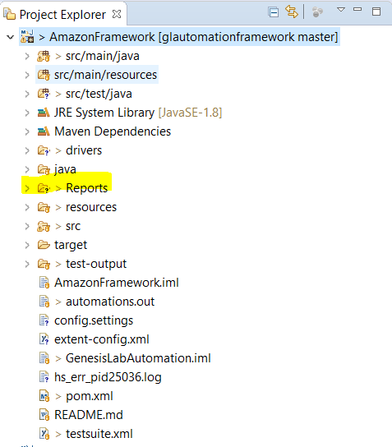

**Pass report**

**Fail report**

Bulk Execution Report.

